ServiceNow Development
Project Documentation

1. Introduction
Project Title: Script-Controlled ACL – Restrict Record Access Based on Field Value
Team ID: SWTID-2026-9989 Date: 25 September 2026
Team Members: see table below (roles follow the sprint allocation).
Team Member | Role / area
Bommanasamy S | Write / create ACL, standard-user list-view scenario
Boopathi S | Role and test-user setup, confidential-viewer scenario
Dharshan P | Delete restriction, owner scenario, reclassification testing
Dheepak Karthik S | Table and field creation, script-controlled read ACL, Update Set export and GitHub repository
Dineshkumar A | Sample data entry, Security Debugger, direct-link scenario, UAT

2. Project Overview
Purpose: Restrict access to individual ServiceNow records based on the value of a field, so that Confidential records are visible only to authorised people.
Features:
- Custom table Secure Records (u_secure_record) with Classification: Public, Internal, Confidential.
- Role u_confidential_viewer for authorised reviewers.
- Script-controlled read, write / create and delete ACLs.
- Owner exception: the record owner can always open their own record.
- Same enforcement on list view, form link, reports and REST Table API.
- Verification with Impersonate User and Security Debugger.

3. Architecture
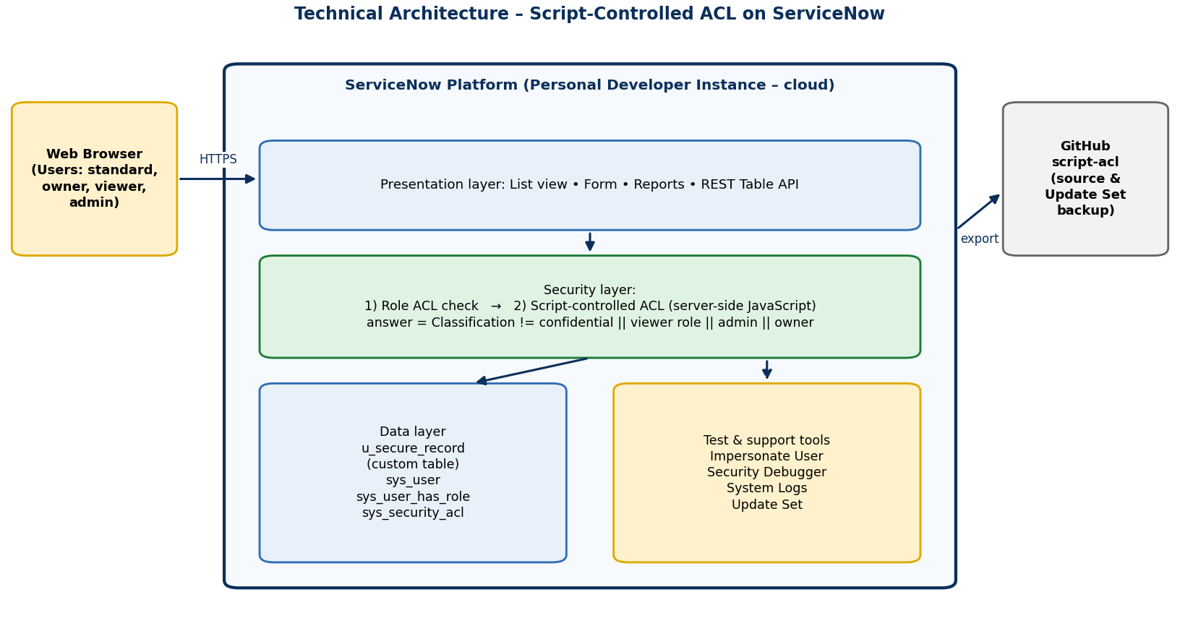
Figure 1: Technical architecture
Frontend: ServiceNow Platform UI – list and form views of the Secure Records table; no custom UI code is required.
Backend: Server-side JavaScript in ACL scripts (current, gs.hasRole, gs.getUserID) evaluated by the platform on every read, write, create and delete.
Database: u_secure_record (Title, Description, Owner [reference to sys_user], Classification [choice]) in the ServiceNow instance database; supporting tables sys_user, sys_user_has_role and sys_security_acl.

4. Setup Instructions
Prerequisites:
- Free ServiceNow developer account (developer.servicenow.com) and a Personal Developer Instance.
- Administrator access to the instance; ability to elevate to security_admin.
- A modern web browser; Git (optional) to clone https://github.com/dkarthik7237/script-acl.git
Installation steps:
- Request a Personal Developer Instance and sign in as admin.
- System Definition > Tables: create Secure Records (u_secure_record) with fields Title, Description, Owner, Classification (Public / Internal / Confidential).
- User Administration > Roles: create u_confidential_viewer.
- User Administration > Users: create a standard user, a confidential viewer (with the role) and a record owner.
- Elevate your role to security_admin.
- System Security > Access Control (ACL): create the read, write (and create) and delete ACLs on u_secure_record and paste the scripts from the Appendix of the Project Report.
- Create sample records with different classifications.
- Optional: import the Update Set from the GitHub repository instead of steps 2–6.

5. Folder Structure
ServiceNow stores the application inside the instance. The GitHub repository holds the exported artefacts; suggested layout (adjust to match your repository):
script-acl/
├── README.md
├── acl-scripts/
│ ├── read_acl.js
│ ├── write_acl.js
│ └── delete_acl.js
├── update-set/
│ └── script_acl_update_set.xml
├── docs/ (phase-wise documents)
└── screenshots/

6. Running the Application
- Open the instance and navigate to Secure Records > All.
- Use System Administration > Impersonate User to switch between the standard user, viewer, owner and admin.
- For each user open the list and the form of a Confidential record and compare with the expected results in the test document.
- Enable System Security > Security Debugger to see the ACL decision for each record.

7. API Documentation
The solution adds no custom endpoints. The standard ServiceNow REST Table API enforces the same ACLs:
Method | Endpoint | Behaviour with the script ACL
GET | /api/now/table/u_secure_record | Returns only the rows the caller may read
GET | /api/now/table/u_secure_record/{sys_id} | Confidential record, unauthorised caller: not returned (typically 404 "No Record found" – record doesn't exist or ACL restricts it)
POST | /api/now/table/u_secure_record | Creates a record if the create ACL allows it
PUT / PATCH | /api/now/table/u_secure_record/{sys_id} | Update of a Confidential record by an unauthorised caller is rejected (typically 403)
DELETE | /api/now/table/u_secure_record/{sys_id} | Allowed for admin only

Example response for a standard user (Confidential rows omitted):
{ "result": [
{ "number": "SR0001", "short_description": "Office Seating Plan", "u_classification": "public" },
{ "number": "SR0002", "short_description": "Team Meeting Notes", "u_classification": "internal" }
] }

Exact error text can differ between ServiceNow releases.

8. Authentication
- Users sign in to the instance with their ServiceNow credentials (session-based in the UI; Basic Auth or OAuth for REST).
- Authorisation is role-based first (table ACL) and record-based second (script ACL).
- The script ACL uses gs.hasRole() for the viewer / admin roles and gs.getUserID() for the owner check; default is deny.
- Changing ACLs needs the security_admin role (elevated privilege).

9. User Interface
The standard ServiceNow list and form are used. The list shows only the records the signed-in user may read; a denied form link shows an access-denied message.
[ Insert screenshot: Secure Records list as standard user ]

[ Insert screenshot: Secure Records list as confidential viewer / admin ]

10. Testing
Strategy: manual functional testing per user type using Impersonate User; negative tests by direct link and by REST API; Security Debugger to confirm the decision; three performance checks (list load time, repeated REST calls, bulk data counts). Results: 15 test cases and 8 UAT cases, all passed – see the Functional & Performance Testing and UAT documents.

11. Screenshots or Demo
GitHub: https://github.com/dkarthik7237/script-acl.git
Demo video: [add link here]
[ Insert screenshot: Read ACL script ]

[ Insert screenshot: Security Debugger output ]

12. Known Issues
- Administrators bypass the rule by design.
- List counts and pagination can differ between users because hidden rows are removed.
- Very large tables may need a Query Business Rule for better performance.

13. Future Enhancements
- Group-based and time-bound access.
- Query Business Rule for database-level filtering.
- Access-request approval workflow.
- ATF automated tests and audit reports.

